CSA 0307-DATA STRUCTURE
CO1-AT2

- Read space-separated integers (may include negatives) from stdin on one line and print the maximum sum of any contiguous subarray (Kadane's algorithm).

#include <stdio.h>

int main() {
int a[1000], n = 0, x;
int curr_sum, max_sum;

while (scanf("%d", &x) == 1) {
a[n++] = x;
}

curr_sum = max_sum = a[0];

for (int i = 1; i < n; i++) {
if (curr_sum + a[i] > a[i])
curr_sum += a[i];
else
curr_sum = a[i];

if (curr_sum > max_sum)
max_sum = curr_sum;
}

printf("%d\n", max_sum);

return 0;
}
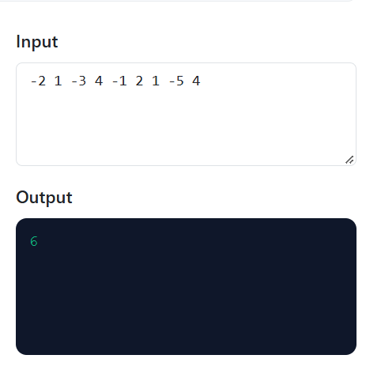
2) Read space-separated integers representing the nodes of a singly linked list (in order) from stdin. Build the linked list and print the value of the middle node. If there are two middle nodes, print the second one.
#include <stdio.h>
#include <stdlib.h>
struct Node {
int data;
struct Node *next;
};

int main() {
struct Node *head = NULL, *tail = NULL, *newnode;
struct Node *slow, *fast;
int x;
while (scanf("%d", &x) == 1) {
newnode = (struct Node *)malloc(sizeof(struct Node));
newnode->data = x;
newnode->next = NULL;

if (head == NULL)
head = newnode;
else
tail->next = newnode;

tail = newnode;
}

slow = fast = head;
while (fast != NULL && fast->next != NULL) {
slow = slow->next;
fast = fast->next->next;
}

if (slow != NULL)
printf("%d\n", slow->data);

return 0;
}

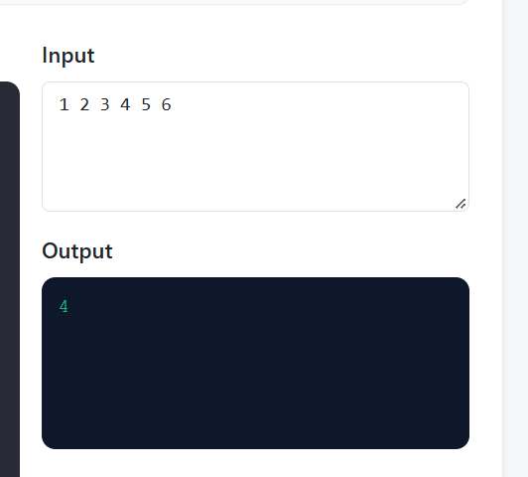

3)Line 1 contains space-separated integers in sorted (non-decreasing) order, possibly with duplicates. Line 2 contains a target integer. Using binary search, print the index (0-based) of the first occurrence of the target, or -1 if it is not present.

#include <stdio.h>
int main() {
int a[1000], n = 0, target, x;
int low, high, mid, result = -1;
while (scanf("%d", &x) == 1) {
a[n++] = x;
if (getchar() == '\n')
break;
}
scanf("%d", &target);
low = 0;
high = n - 1;
while (low <= high) {
mid = low + (high - low) / 2;
if (a[mid] == target) {
result = mid;
high = mid - 1;
} else if (a[mid] < target) {
low = mid + 1;
} else {
high = mid - 1;
}
}
printf("%d\n", result);
return 0;
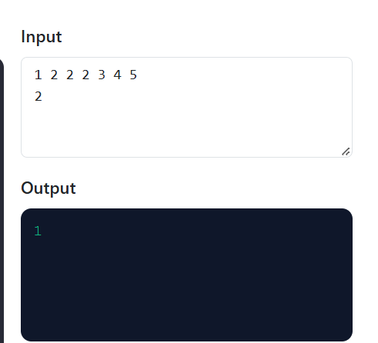
}

4)Read a string consisting only of the characters ( ) { } [ ] from stdin. Using a stack, print True if the brackets are balanced, o#include <stdio.h>

int main() {
char s[1000], stack[1000];
int top = -1, balanced = 1;
scanf("%999s", s);
for (int i = 0; s[i] != '\0'; i++) {
if (s[i] == '(' || s[i] == '{' || s[i] == '[') {
stack[++top] = s[i];
} else {
if (top == -1) {
balanced = 0;
break;
}
char ch = stack[top--];
if ((s[i] == ')' && ch != '(') ||
(s[i] == '}' && ch != '{') ||
(s[i] == ']' && ch != '[')) {
balanced = 0;
break;
}
}
}
if (top != -1)
balanced = 0;
printf("%s\n", balanced ? "True" : "False");
return 0;
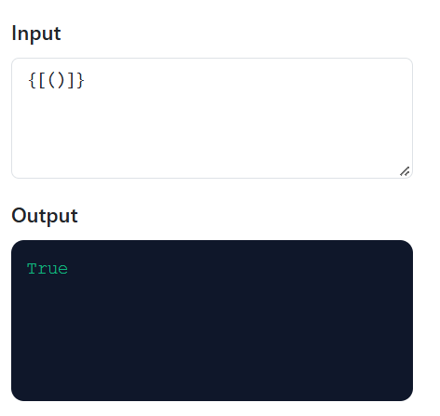
}therwise print False.

5) Line 1 contains space-separated integers. Line 2 contains an integer k (window size). Using a deque (queue), print the maximum of every contiguous window of size k as space-separated values.

#include <stdio.h>
int main() {
int a[1000], dq[1000];
int n = 0, x, k;
int front = 0, rear = -1;
while (scanf("%d", &x) == 1) {
a[n++] = x;
if (getchar() == '\n')
break;
}
scanf("%d", &k);
if (k <= 0 || k > n)
return 0;
for (int i = 0; i < n; i++) {
while (front <= rear && dq[front] <= i - k)
front++;
while (front <= rear && a[dq[rear]] <= a[i])
rear--;

dq[++rear] = i;
if (i >= k - 1) {
if (i > k - 1)
printf(" ");
printf("%d", a[dq[front]]);
}
}
printf("\n");
return 0;



